Decision Analysis in R for Technologies in Health

Exercises

Fernando Alarid-Escudero, PhD¹
Eva A. Enns, MS, PhD¹
M.G. Myriam Hunink, MD, PhD^{2,3}
Hawre J. Jalal, MD, PhD⁴

Eline M. Krijkamp, MSc²
Petros Pechlivanoglou, PhD⁵

Acknowledgements and attribution.
Please cite the following papers when using any of the material:
Jalal H, et al. An Overview of R in Health Decision Sciences. Med. Decis. Making. 2017; 37(3): 735-746.
Krijkamp EM, et al. Microsimulation modeling for health decision sciences using R: a tutorial. Med. Decis. Making. 2018; (in press).
Enns, E. A., Cipriano, L. E., Simons, C. T., & Kong, C. Y. (2015). Identifying Best-Fitting Inputs in Health-Economic Model Calibration: A Pareto Frontier Approach. Med. Decis. Making, 35(2), 170–182.

In collaboration of:
¹ University of Minnesota School of Public Health, Minneapolis, MN, USA

² Erasmus MC, Rotterdam, The Netherlands

³ Harvard T.H. Chan School of Public Health, Boston, USA
⁴ University of Pittsburgh Graduate School of Public Health, Pittsburgh, PA, USA
⁵ The Hospital for Sick Children, Toronto and University of Toronto, Toronto ON, Canada

© Copyright 2017, THE HOSPITAL FOR SICK CHILDREN AND THE COLLABORATING INSTITUTIONS. All rights reserved in Canada, the United States and worldwide. Copyright, trademarks, trade names and any and all associated intellectual property are exclusively owned by THE HOSPITAL FOR SICK CHILDREN and the collaborating institutions and may not be used, reproduced, modified, distributed or adapted in any way without written permission.

Title | The Sick-Sicker model – A Markov cohort model
Topic | Markov model
Learning objective | To digest the R code presented during the Markov model course  To be able to build a Markov model  To be able to do a CE-analysis  To be able to make basic plots and tables
Specifications | Markov model, 4 health states, 2 strategies
Duration | 45 - 60 minutes
Needed | Exercise instruction, R, R-studio

Exercise I: The Sick-Sicker model – A Markov model
A hypothetical disease affects individuals with an average age of 25 years and results in increased mortality, increased treatment costs and reduced quality of life. The disease has two levels; affected individuals initially become sick but can subsequently progress and become sicker. Two alternative strategies exist for this hypothetical disease: a no-treatment and a treatment strategy. Under the treatment strategy, individuals who become sick or progress and become sicker receive treatment and continue doing so until they recover or die. The cost of the treatment is additional to the cost of being sick or sicker for one year. The treatment improves quality of life for those individuals who are sick but has no effect on the quality of life of those who are sicker. You are asked to evaluate the cost-effectiveness of the treatment.
To model this disease, we will rely on a state-transition cohort model, called the Sick-Sicker model, first described by Enns et al. The Sick-Sicker model consists of four health states: healthy (H), two disease states sick (S1) and sicker (S2) and dead (D) (Figure 1). All individuals start in the healthy state. Over time, healthy individuals may develop the disease and can progress to S1. Individuals in S1 can recover (return to state H), progress further to S2 or die. Individuals in S2 cannot recover (i.e. cannot transition to either S1 or H). Individuals in H are assumed to have a fixed mortality rate and individuals in S1 and S2 have an increased mortality rate compared to healthy individuals. These rates are used to calculate the probabilities to die when in S1 and S2.

Input parameters
Parameter | Variable name in R | Value
Time horizon | n.t | 30 years
Cycle length |  | 1 year
Names of health states (n) | v.n | H, S1, S2, D
Annual discount rate (costs/QALYs) (d.r) | d.r | 3%
Annual transition probabilities
Disease onset (Η to S1) | p.HS1 | 0.15
Recovery (S1 to Η) | p.S1H | 0.5
Disease progression (S1 to S2) | p.S1S2 | 0.105
Annual probability of death
H to D | p.HD | 0.005
Hazard rate ratio of death in S1 vs healthy | rr.S1 | 3
Hazard rate ratio of death in S2 vs healthy | rr.S2 | 10
Annual costs
Healthy individuals | c.H | $2000
Sick individuals in S1 | c.S1 | $4000
Sick individuals in S2 | c.S2 | $15000
Additional annual treatment cost per sick individual (S1 and S2) | c.Trt | $12000
Utility weights
Healthy individuals | u.H | 1.00
Sick individuals in S1 | u.S1 | 0.75
Sick individuals in S2 | u.S2 | 0.50
Intervention effect
Utility for treated individuals in S1 | u.Trt | 0.95
Hint: p.S1D and p.S2D can be calculated using the formulas: $r=-log⁡(1-p)$ and $p=1-e^{(-rt)}$

Figure 1: Schematic representation of the Sick-Sicker model
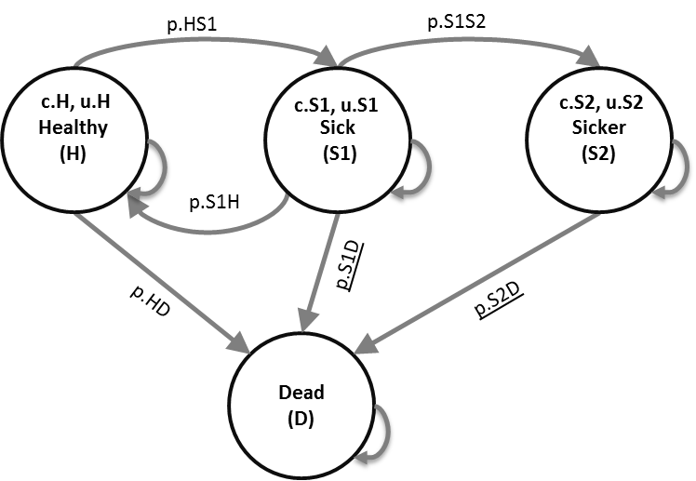

Tasks
- Build the Markov model in R for no-treatment and treatment.
- Create a survival probability plot.
- Estimate the cost-effectiveness of treatment vs no-treatment.
- Create a cost-effectiveness table with all results of interest.
- Export the table in a .txt file.
- Perform a one-way sensitivity analysis for the results in the treatment strategy arm using the following values:
  - p.HD where the variable ranges between 0.002 and 0.01.
  - c.trt where the variable ranges between $6000 and $18000.
  - u.S2 where the variable ranges between 0.40 and 0.70.

Title | Age specific mortality – The Sick-Sicker Markov Model
Topic | Markov model
Learning objective | To digest the R code presented during the Markov model course  To be able to build a Markov model  To be able to use real age specific mortality rates
Specifications | Markov model, 4 health states, 2 strategies
Duration | 45 - 60 minutes
Needed | Exercise instruction, R, R-studio, packages HMDHFplus

Exercise II: Age specific mortality – The Sick-Sicker Markov model
This exercise continues based on the time-homogeneous Markov model of the Sick-Sicker model form exercise I.
Healthy individuals are no longer assumed to have a fixed mortality rate. Their mortality rate depends on their age. The Human Mortality Database (HMD) (www.mortality.org) provides these age specific mortality rates (Mx1x1). You can load this data in R using different packages, for example the HMDHFplus, demography or data.table package. Registration (free) on the HMD website is required in order to use the data.
Remember: individuals in S1 and S2 have an increased mortality rate compared to healthy individuals as described in exercise I. The same rates are used to calculate the probabilities to die when in S1 and S2 in this exercise.
Before you start coding exercise II, please create a copy the code from exercise I or save the code as a separate .R file. You need this basic model structure for exercise III.

Tasks
- Import the death rate data (Mx 1x1) for a country of interest (e.g. USA, CHE, CAN, NOR) from the HMD and store this data in a variable.
You can make use of the HMDHFplus package
  - HMDHFplus:
    - us <- "YOUR EMAIL"
    - pw <- "YOUR PASSWORD"
    - data.r_HD <- readHMDweb(CNTRY = "USA", item = "Mx_1x1",
username = us, password = pw)
- Keep only the data from a specific year you are interested in (e.g. 2015 if available), for the ages 25-55 and the overall (no sex specific) mortality data.
- data.r_HD <- data.r_HD[data.r_HD $Year == 2015]]
- data.r_HD <- subset(data.r_HD [26:56], select = c("Age", "Total"))
- Incorporate the age dependent mortality rate in the model using one of the approaches.
- Create a survival probability plot
  - Extra challenge: add the lines from both exercise II and exercise I in one graph so you can compare.
- Estimate the cost-effectiveness of treatment vs no-treatment.
- Create a cost-effectiveness table with all results of interest.
- Export the table in a .txt file.

Title | Probabilistic version Sick-Sicker– A Markov cohort model
Topic | Probabilistic Markov model
Learning objective | To digest the R code presented during the probabilistic analysis part of the course  To be able to do a probabilistic analysis for a Markov model
Specifications | Markov model, 4 health states, 2 strategies, distributions, PSA
Duration | 30 minutes
Needed | Exercise instruction, R, R-studio, package truncnorm

Exercise III: Probabilistic version Sick-Sicker – A Markov model
This exercise continues based on the time-homogeneous deterministic Markov model of the Sick-Sicker model form exercise I. In this exercise you will do a probabilistic analysis with 1000 simulations (n.sim). Table 2 described the distributions for the variables you used in exercise I.

Table 2: Input parameters for probabilistic analysis
Parameter | Distribution | Distribution values
Number of simulation  Annual transition probabilities | n.sim | 1000
Disease onset (Η to S1) | Beta | a = 30, b = 200
Recovery (S1 to Η) | Beta | a = 60, b = 120
Disease progression (S1 to S2) | Beta | a = 84, b = 800
Annual probability of death
H to D | Beta | a = 10, b = 2,000
Rate ratio of death in S1 vs healthy | Lognormal | μ = log(3), σ = 0.01
Rate ratio of death in S2 vs healthy | Lognormal | μ =log(10), σ = 0.02
Annual costs
Healthy individuals | Gamma | shape = 100, scale = 20
Sick individuals in S1 | Gamma | shape = 177.8, scale = 22.5
Sick individuals in S2 | Gamma | shape = 225, scale = 66.7
Annual treatment cost per sick individual (S1 and S2) | Gamma | shape = 73.5, scale = 163.3
Utility weights
Healthy individuals | Tr. Normal | μ = 1.00, σ = 0.01, b=1
Sick individuals in S1 | Tr. Normal | μ = 0.75, σ = 0.02, b=1
Sick individuals in S2 | Tr. Normal | μ = 0.50, σ = 0.03, b=1
Intervention effect
Utility for treated individuals in S1 | Tr. Normal | μ = 0.95, σ = 0.02, b=1

Tasks
- Make a copy of your R code from exercise I and paste this in your file or save this copy as exercise III. In this exercise we will do the PSA without time varying variables.
- Generate values for the uncertain parameters using the appropriate distributions.
- Hint: package truncnorm deals with truncated normal distributions.
- Conduct a Probabilistic Cost-Effectiveness analysis of treatment vs no-treatment
- Create histograms of discounted costs and discounted QALYs.
- Create a cost-effectiveness plane to present incremental costs (discounted and incremental QALYs (discounted).
- Create an expected value of perfect information (EVPI) plot. Expected Value of Perfect Information (EVPI)
- Create a cost-effectiveness acceptability curve for the treatment comparison assuming WTP thresholds of $0 to $200,000.
- Export the plots on .pdf files.

Results

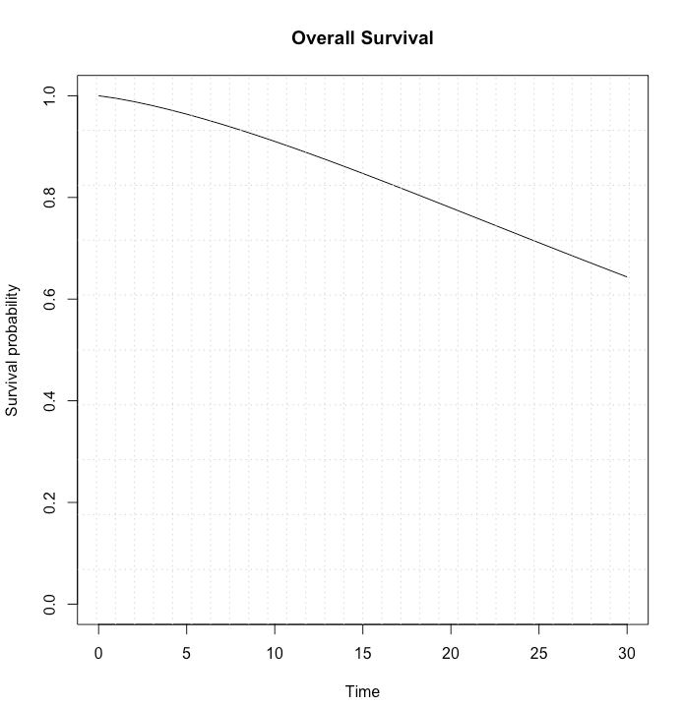
Exercise I
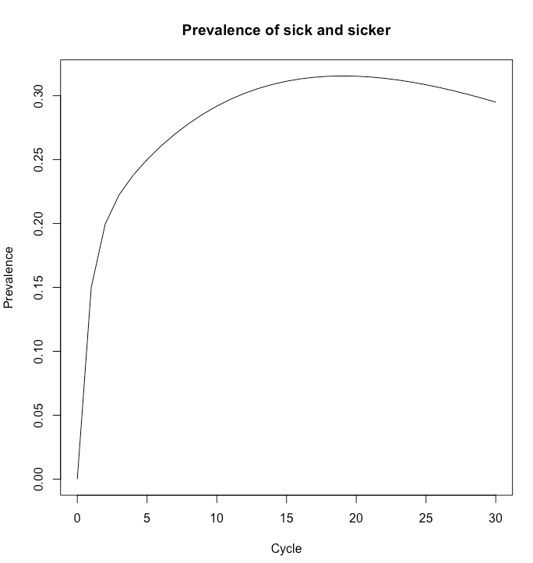
 | Strategies | C | E | DC | DE | ICER
1 | Control | 75976.15 | 15.84
2 | Treatment | 141623.03 | 16.4 | 65646.88 | 0.56 | 116901.38

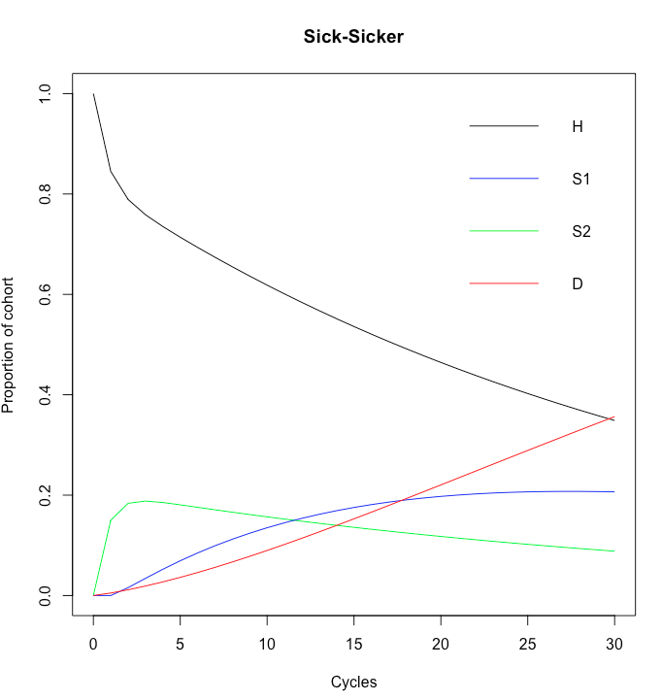

Strategies | Basecase | Low | high
p.HD | 141623 | 145087.6 | 136130.2
c.Trt | 141623 | 108799.6 | 174446.5
u.S2 | 141623 | 141623 | 141623
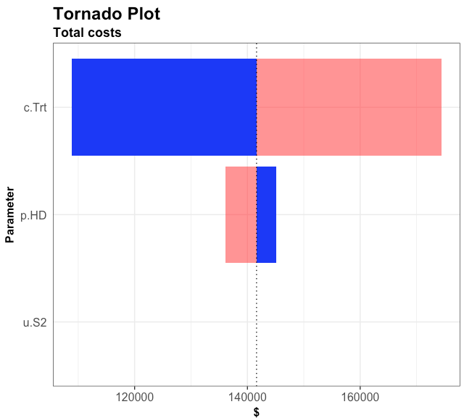

Exercise II
These results a created using US 2015 mortality rates.
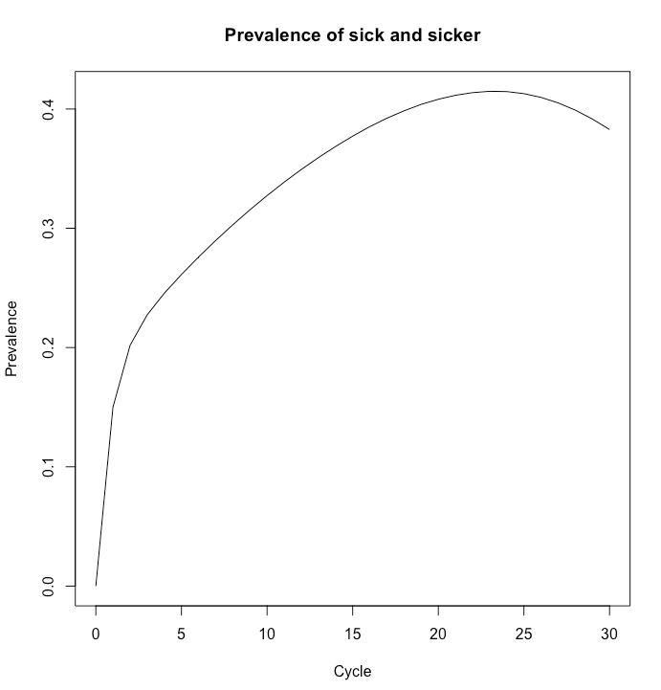
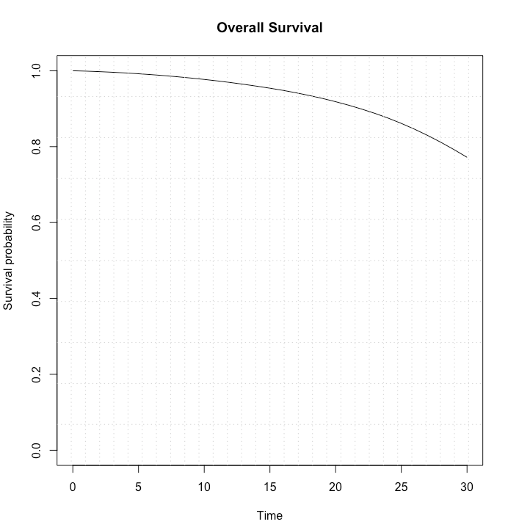
 | Strategies | C | E | DC | DE | ICER
1 | No treatment | 90473.6 | 17.01
2 | Treatment | 168299.9 | 17.61 | 77826.3 | 0.6 | 130312.7
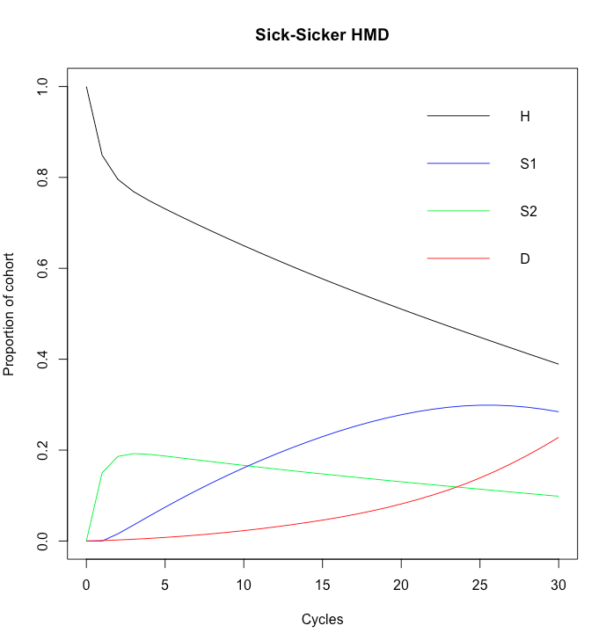

Exercise III

